##### APPENDIX 1

##### TRAVEL WEBSITE

##### A MINOR PROJECT REPORT

###### ***Submitted by***

##### ERIC GONSALVES(RA1511008010493)

**PIYUSH KUMAR MAURYA(RA1511008010582)**

**GULSHAN KUMAR(RA1511008010589)**

##### SUYASH V EKRE(RA151100801523)

##### YASH NITIN DESAI(RA1511008010521)

***in partial fulfillment for the award of the degree***

***of***

##### B.TECH.

IN

INFORMATION TECHNOLOGY



SRM UNIVERSITY

KATTANKULATHUR

MAY 2018

APPENDIX 2

SRM UNIVERSITY

KATTANKULATHUR

**BONAFIDE CERTIFICATE**

Certified that this project report **“TRAVEL WEBSITE”** is the bonafide work of **YASH DESAI – SUYASH EKRE–GULSHAN KUMAR- PIYUSH KUMAR – ERIC GONSALVES”** who carried out the project work under my supervision.

**SIGNATURE SIGNATURE**

**Guide Name**

**HEAD OF THE DEPARTMENT Information Technology**

INTERNAL EXAMINER

**DECLARATION**

We Yash Nitin Desai(RA1511008010521),Suyash Ekre(RA1511008010523), GulshanKumar(RA1511008010589),Piyush Kumar Maurya(RA1511008010582),Eric Gonsalves(RA1511008010493) studying in III year B.Tech Information Technology program at, SRM Institute of Science &Technology, Kattankulathur, Chennai, hereby declare that this project is an original work of mine and I have not verbatim copied / duplicated any material from sources like internet or from print media, excepting some vital company information / statistics and data that is provided by the company itself.

Signature of the Student

Date:

Place:

**ACKNOWLEDGEMENT**

The success and the final outcome of this project required guidance and assistance from different sources and we feel extremely fortunate to have got this all along the completion of our project. Whatever we have done is largely due to such guidance and assistance and we would not forget to thank them.

We express our sincere thanks to the Head of the Department, Department of Information Technology, Dr.G.Vadivu, for all the help and infrastructure provided to us to complete this project successfully and his valuable guidance.

We owe our profound gratitude to our project guide **Ms. RAZIA SULTHANA**, who took keen interest in our project work and guided us all along, till the completion of our project work by providing all the necessary information for developing a good system.

We are thankful to and fortunate enough to get constant encouragement, support and guidance from all the Teaching staff of the Department of Information Technology which helped us in successfully completing our minor project work. Also, we would like to extend our sincere regards to all the non-teaching staff of the department of Information Technology for their timely support.

Yash Nitin Desai(RA1511008010521),

Suyash Ekre(RA1511008010523),

GulshanKumar(RA1511008010589),

Piyush Kumar Maurya(RA1511008010582),

Eric Gonsalves(RA1511008010493)

**TABLE OF CONTENTS**

**CHAPTER NO. TITLE PAGE NO.**

**ABSTRACT I**

**LIST OF FIGURES II**

**1. INTRODUCTION 1**

1.1 GENERAL 1

1.2 . . . . . . . . . . . . . 2

1.2.1 General 5

1.2.2 . . . . . . . . . . . 12

1.2.2.1 General 19

1.2.2.2 . . . . . . . . . . 25

1.2.2.3 . . . . . . . . . . 29

1.2.3 . . . . . . . . . . . . 30

1.3 . . . . . . . . . . .. . . . . . . 45

1.4 . . . . . . . . . . . . . . . . . . 58

**2. REQUIREMENT ANALYSIS 69**

2.1 GENERAL 75

* 1. . . . . . . . . . 99

2.2 ……………. 100

**ABSTRACT**

The website will serve as an online platform where people would be able to search and plan their trip and search places according to the type of experience and the weather they want, and get all the information they need for the nearby places.

Upon opening the site , the user will be given an array of options to start with.The user will see available categories laid out on the home page, that’s fully interactive and lets you see the details of the destination selected with an arresting image. The user will also be provided with the near by points of interests. Based on the location they choose the nearby destinations will pop up.

The site will showcase its users locations incredibly well with screen-filling glory. You’re also not bombarded by rows upon rows of thumbnails, just a handful of well-chosen pictures, which you can cycle through at your own pace.The website will have an easy to use and interactive button group panel.  The panel will display the weather types (e.g. cloudy, sunny, rainy, snow etc.).

The users will then select the weather he would like. The site will then generate the places according to the weather selected. The site will check the real-time weather of all the places that are in the selected category and display those which have the selected weather.

The website will has a great and easy to view map which displays the position of the places the user searches. The map has various checkboxes which will pop the nearby places of interests. This will give the user a great detail about the place they are are going to visit.

The website will provide a completely different approach to knowing the places people want to travel.

**LIST OF FIGURES**

1. **DATA- FLOW DIAGRAM OF TRAVEL**

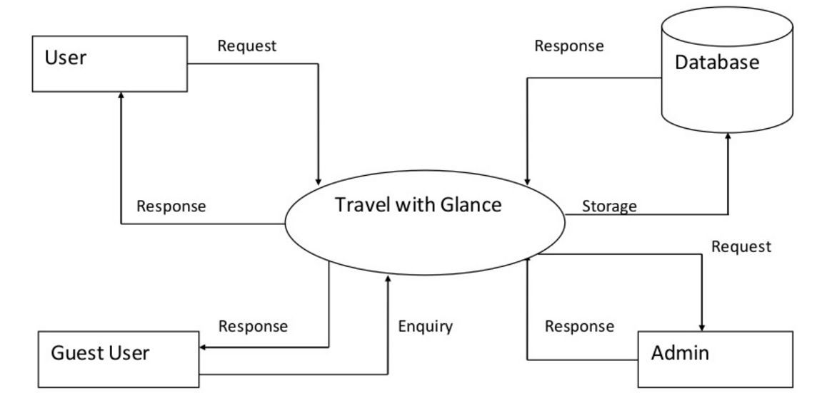

**CHAPTER 1**

**INTRODUCTION**

**1.1 GENERAL**

The Travel Website is a web based application. The main purpose of “TRAVEL ” is to provide a convenient way for a customer to find their place of interest. The objective of this project is to develop a system that makes the user select the environment they want.. In this project, We will make an easier task of searching places and providing our customers the weather conditions they prefer. In the present system a customer has to select the place they want to visit sometimes unaware of the climatic. This often requires a lot of time and effort. We provide approach skills to critically examine how a tourist visits and its ability to operate in an appropriate way when dealing with the consequences of tourism.

This application lets you choose the weather of the place to according to which the result is provided to the user according to the type of place and weather they want to experience. The application provide a refined result of the places according to the options choose by the user.Thus it provides the proper result of the places for the user in which they are interested for a tour.

**1.2 OBJECTIVE**

The web application will serve as an online platform where people would be able to choose a place for their trip according to the experience that the user would want to have.Further the user also has an option to select the weather according to their wish.

**1.3 PROBLEM STATEMENT**

* **What is the problem?**

People often get confused selecting the proper place or spot for making their trip perfect,many times the people are not aware of the places they are looking for and also the weather conditions they are lokking for.

* **Who faces the problem?**

People who generally look for a tourist place planning for their trip.

* **How do we resolve the problem?**

A dedicated website where the user is provided with a category of different experiences people can choose from and they are also provided with the option of the kind of weather conditions they are looking for.

**1.4** **LITERATURE REVIEW**

First, the userchooses from the options of different types of experiences, they would prefer for a particular vacation. They are provided with different categories such as adventure, luxury etc.

The user then will be asked for the type of weather they would prefer to enjoy according to their favoured category or experience.

The user will then get the list of places according to the category they chose. Further the user will be asked to select a weather condition thay would like.

The site will then generate the places which currently have the selected weather conditions.

The user will also be provided with a map which will display the nearby points of interests such as bus stops, restaurents etc. This will give the user a rought idea of the place they will be planning to go to.

**1.5 SOFTWARE REQUIREMENTS**

For Developers

* Text Editor
* Netbeans IDE
* MySQL server
* Apache server
* Xampp
* Bootstrap

For Clients

Supported Browsers –

* Internet Explorer
* Google Chrome
* Safari
* Mozilla Firefox

**1.6 HARDWARE REQUIREMENTS**

* RAM – 4GB or more
* Processor – Dual core or above

**1.7 EXISTING METHODOLOGIES:**

* The site provides a system for the user to select a location.
* The user then selects the tour packages available for the location.
* The site provides booking system for hotels, flights, etc.
* The user needs to look for the particular location in which he/she is interested.
* The information is provided for the particular places the user is looking for.

**1.7 DEVELOPING METHODOLOGIES:**

* The site provides various categories of places according to which user can select.
* Various categories includes types of choices of place like Heritage,Spiritual etc.
* The user then gets to choose the type of weather the user is interested.
* The options of weather like Sunny, Cloudy, etc, the user gets to choose the desired weather they are interested to experience.
* The site then provides the name of the places according to the input of the user.

**CHAPTER 2**

**2. REQUIREMENT ANALYSIS**

Requirement analysis is a critical first step, It implies to website designer, web consultant or a business owner and true for web design as well mobile application design.

Instead of running directly to any creative web design agency or your in-house team of web designers and start designing process immediately, a brief discussion and requirement analysis is evident

**2.1. Steps we followed for requirment analysis**

Analysis process less or more can be inherited in these steps:

1. Initial discussion with the client and collecting requirement
2. Structuring requirement into different categories
3. Negotiating priorities, highlights, colour essentials
4. Evaluating requirements against established criteria, re-structuring requirement.
5. Conceptual design
6. Brainstorming conceptual designs with the client/decision makers.
7. Making requirement changes in structure and moving ahead with the final design process.

**2.2 Requirment of our website**

**User Interface Design**

The user interface design in very minimalistic and easy to use where we use the pictures of places and description of the place to make the site more interactive and informative.The login and choosing of categories in easy and there is a classified and easy to choose menu to select the weather based on user preference. Good user interface design facilitates finishing the task at hand without drawing unnecessary attention to itself. Graphic design and typography are utilized to support its usability, influencing how the user performs certain interactions and improving the aesthetic appeal of the design; design aesthetics may enhance or detract from the ability of users to use the functions of the interface. The design process must balance technical functionality and visual elements (e.g., mental model) to create a system that is not only operational but also usable and adaptable to changing user needs.

**Future Enhancements**

Currently the site generates places based on the current weather conditions. We are planning to include a feature that would let the user know the places, with weather conditions for the next 10-15 days.

This would be done by extracting data from weather sites, the data that is to be extracted should contain the entire forecast for the next 15 days. Therefore, the user can book a place in advance but knowing the weather beforehand.

**Approach**

After working out all the elements which will be on each webpage and the basic flow of the website, we created a interactive design for our website. Our website used images for icons and interactive button groups for takeing input from the user. After the design and coding ,we started collecting content and making databases for all the places.At the end we linked database to web page and and segregate them by the weather conditions at that location. The weather conditions are extracted from the OpenWeatherMap website using an API.

**Testing Process & Plan**

Softwaretesting is a process of executing a program or application with the intent of finding the softwarebugs. It can also be stated as the process of validating and verifying that a software program or application or product: Meets the business and technical requirements that guided it's design and development.

Testing the application before it is presented to the users for using is very important. All the links and validations have been tested through black box and white box testing .We have tested all possible paths to the links in white box testing and checked all services we provide for blackbox testing.

**What all I Needed from The Client**

We require the user to create an account, the login page is linked on the home page.the user then selects the category they want (type of experience i.e. adventure, luxury) from all the different options provided on the website. The user then selects the weather condition they want from the options provided. The user then gets the filtered places to choose from. The site provides a map that displays the nearby place.

**Third Party Tools**

The third party tools we use are airline and hotel websites to book reservations.

**Technology Implementation**

* Which server side scripting language will be used for development – PHP,
* Client side scripting -Java Script, HTML, CSS, Bootstrap
* Database Server for website and user generated contents – MySQL
* OS platform that will be required for hosting the website-windows ,XAMPP or WAMP.

**CHAPTER 3**

**DESIGN**

The Given Design Challenge which is stated in the starting of this document demanded that we frame a dynamic database driven website. Broadly this website should be able to portrait dynamic content on a webpage as well as give the user interactive input sessions.These challenges demanded some research which led to the following conclusion -

**3.1 What Do We Need?**

1. A server side scripting language that would process data on the request of the user.

2. An effective way of storing all the data which the website uses to output the results.In short a Database management System.

3. A query language to effectively retrieve ,alter and add to the stored data in our database.

4. An interface to represent the output of the scripting language in the form of html.

5. A web server which is needed to host the website and to do all the computations needed to portrait the generated data on the basis of input received from the user.

6. A query language to effectively retrieve the weather conditions for the given place .

**3.2 Available Choices**

Server Side Scripting Language

1. PHP(which we used)-

server-side scripting language designed for web development but also used as a general-purpose programming language. It was originally created by Rasmus Lerdorf in 1994,[[3]](https://en.wikipedia.org/wiki/PHP" \l "cite_note-History_of_PHP-3) the PHP reference implementation is now produced by The PHP Group.[[4]](https://en.wikipedia.org/wiki/PHP#cite_note-about_PHP-4) PHP originally stood for *Personal Home Page*,[[3]](https://en.wikipedia.org/wiki/PHP" \l "cite_note-History_of_PHP-3) but it now stands for the recursive acronym *PHP: Hypertext Preprocessor*

2. JSP(Java Server Pages)-is a java technology that facilitates software developers to dynamically generate html,xml and other kind of documents.It is also a platform independent technology. JavaServer Pages (**JSP**) is a technology that helps software developers create dynamically generated web pages based on HTML, XML, or other document types. Released in 1999 by Sun Microsystems, **JSP** is similar to PHP and ASP, but it uses the Java programming language.

3. HTML and CSS(which we used to make a user interface)-It is a fairly simple language made up of elements, which can be applied to pieces of text to give them different meaning in a document and embed content such as images and videos into a page. Hypertext Markup Language is the standard markup language for creating web pages and web applications. With Cascading Style Sheets and JavaScript, it forms a triad of cornerstone technologies for the World Wide Web.

4. Javascript (used to validate data)-JavaScript is a lightweight, interpreted programming language. It is designed for creating network-centric applications. It is complementary to and integrated with Java. JavaScript is very easy to implement because it is integrated with HTML. It is open and cross-platform.

5. Bootstrap(used to make interface more interactive)- Bootstrap is a free and open-source front-end library for designing websites and web applications. It contains HTML- and CSS-based design templates for typography, forms, buttons, navigation etc.

Database management System

1. MYSQL(which we used)- MySQL is an open-source relational database management system. Its name is a combination of "My", the name of co-founder Michael Widenius's daughter, and "SQL", the abbreviation for Structured Query Language.

* 1. **Choice made**

1. PHP as the server side scripting language with apache2.2 as the server facilitating the processing of PHP code including the frontend in HTML and styling done through bootstrap and CSS.

2. MYSQL as the relational database management system and sql as our query language.

**3.4 Arguments leading to choice made**

1. PHP became the first choice because of its platform independency and it's widespread use as a web development scripting language giving it a edge over other alternatives. Also it is a open source software and has many built in functions to facilitates common practical problems.

2. MYSQL became a choice as it is too a platform independent software and works very well with php .

3. PHP facilitates very good communication with the MYSQL database.

Now the server-Apache was taken as it is a open source project and can be found easily on the internet.

**3.5 Development Process**

The following is the process through which we planned our development.

1. Planning and assignment of reading work to individuals

2. Reading up material for new technologies to be used

3. Deciding what technologies to use and distribution of work among group members

4. Individual work on independent components

5. Integration of the core services o ered.

6. Embedding of core code into a standard html template, create links among all of all static and dynamic pages.

7. Putting it all together in the form of a software package.

**CHAPTER 4**

**IMPLEMENTATION**

**4.1 Front End development**

The front end has been developed using HTML, CSS, PHP, JavaScript, and Bootstrap. We have made it highly user friendly so that any one is able to use it. We have made five basic modules that explains the whole website as a whole, they contain- Home, About us and Contact us. These modules are developed with the help of the languages before. We have tried to make all home page as simple yet user interactive at the same time. For people who have any queries can send us a text using the feedback form which will be included in the SQL database and for regular newsletters any client/customer can subscribe.

**4.2 Back End development**

The back end of the project is coded in Java and PHP. The major features of the back end of the project can be illustrated as under.

We have used some queries. Any database operation whatsoever is performed using SQL Data Source. Using them gives an added advantage of security, as the issues related with non-use of parameterized queries is already taken care of.

* Use of MySQL tables instead of Data Grid Views so as to endure more first-hand exposure to manual binding of data to controls.

* Storage of images used for the place tabs are inside the project folder, and binding them to a particular image ID inside database, instead of saving actual images inside database, ensures smoothness.

**4.3 Database Structuring**

There are 2 data tables have been used to manage the data we store. A brief

description of the same is as follows.

1. Places: This tables store all factual information about the city of choice. This include name, state, country, type of experience it would provide.

2. user\_login: This table stores all the email addresses of the user on the website.

**MODULES**

**1. Admin**

A Website Administrator has a broad range of administrative privileges across a single website, primarily managing the infrastructure of site content (such as templates, style sheets, and processes). He or she performs the following site-wide tasks: Create and manage CMS wrappers, Create and manage content types, Create content filters, Create and manage content categories, Set default configurations for page-level components, Create and manage custom approval work flows, Create and manage style sheets (CSS files), Create and manage internal RSS feeds, Create and manage display templates for RSS feeds, Revoke a person's role as Website Administrator. (Only Blackbaudsupport can assign the Website Administrator role, to an individual or a group.), Select the security group types available in Folder Permissions when a Folder Manager searches for an individual or a group to assign a folder-level role, Approve or reject content, Bulk Approve, Approve or Reject Comments, Review content in custom work flow.

**1.1 Registration(Login)-**

The registration or login form is for the customers who believe in keeping a contact or storing their information which is free of cost and only publicises the relationship of the customer with us. This form gets all the personal information of the customer which helps us know the name, email, address, phone number and some more personal agendas about the client. This in turn helps us get knowledge about the age group, personal info that helps in making our service to them more available and accurate to their interests. This information is supposed to be secured and these information should be correctly filled.

The login page is not a compulsory option a customer can visit the site and leave as well. The details are stored in the registration table in MySQL and verified using PHP and javascript. This is just to create a long term relationship with a client that helps us get the response and accuracy in our system.

**2.Categories module**

User can view and select categories for tourist. User can select any category from this module he can also check the details of various places. A user can select any category from this module.

**2.1 The change**

Our website is different from other existing travel websites as our websetes provides a completely different approach to selecting holiday places.Users can select the place of travel from a wide range of different categories according to their specifications.the packages are distributed of the basis of :

* The type of experience they provide (e.g. adventure, luxury etc.).
* Weather conditions of the place.

**2.2 Flow of data**

Once the user selects which type of experience they want they are taken to the next page with options of all the places under the said list .the user can then select what weather they want.Once that is done this data is extracted from the OpenWeatherMap.org. The places in that category with the selected weather conditions are displayed. The user can then search the place in the map provided to view nearby places.

1. **Traveller**

Online Travel Website is a software web application to generate the places of Interest. Presently this website will selecting places based on the experience and weather of that place for all type of travelers this website provides a solution to choose travel places in a completely different way.

Travelers’ preference and preferences vary widely, but can be grouped into broad categories:

* Adventure
* Luxury
* Spiritual
* Heritage

Travelers play an extremely important role in our project as the entire project is not only made for the convenience of the client but is designed to meet all their needs and preferences. A traveler can either register or login, if he/she has already registered before by giving his/her details, he can simply log in and visit the web site as well give

**PROGRAMS:**

<?php session\_start(); ?>

<!DOCTYPE html>

<html>

<title>MOOD</title>

<meta charset="UTF-8">

<meta name="viewport" content="width=device-width, initial-scale=1">

< link rel="stylesheet" href="index.css">

<link rel="stylesheet" type="text/css" href="https://maxcdn.bootstrapcdn.com/bootstrap/3.3.5/css/bootstrap.min.css">

<script src="https://ajax.googleapis.com/ajax/libs/jquery/3.3.1/jquery.min.js"></script>

<script src="https://maxcdn.bootstrapcdn.com/bootstrap/3.3.7/js/bootstrap.min.js"></script>

<script type="text/javascript" src="weather.js"></script>

<style>

.navbar{

margin:0px;

}

.container{

display: flex;

justify-content: center;

align-items: center;

}

.container{

margin: 4% auto;

}

#icon {

max-width: 200px;

margin: 5% auto;

}

.wetbtn{

width:500px

height:300px;

}

.elements{

background-color:white;

}

</style>

<body>

<nav class="navbar navbar-inverse">

<div class="container-fluid">

<div class="navbar-header">

<button type="button" class="navbar-toggle" data-toggle="collapse" data-target="#myNavbar">

<span class="icon-bar"></span>

<span class="icon-bar"></span>

<span class="icon-bar"></span>

</button>

<a class="navbar-brand" href="#">TRAVEL</a>

</div>

<div class="collapse navbar-collapse" id="myNavbar">

<ul class="nav navbar-nav">

<li class="active"><a href="#index.html">Home</a></li>

<li class="dropdown"><a class="dropdown-toggle" data-toggle="dropdown" href="#">Support <span class="caret"></span></a>

<ul class="dropdown-menu">

<li><a href="#">Contact Us</a></li>

<li><a href="#">About Us</a></li>

</ul>

</li>

<li><a href="explore.html">Explore</a></li>

</ul>

<ul class="nav navbar-nav navbar-right">

<li><a href="home.html"><span ></span> <?php echo $\_SESSION['user']; ?></a></li>

<li><a href="logout.php"><span class="glyphicon glyphicon-log-in"></span> Logout</a></li>

</ul>

</div>

</div>

</nav>

<!-- login page -->

<div class="modal fade" id="login-modal" tabindex="-1" role="dialog" aria-labelledby="myModalLabel" aria-hidden="true" style="display: none;">

<div class="modal-dialog">

<div class="loginmodal-container">

<h1>Login to Your Account</h1><br>

<form method="post" action="CheckUserLogin.php">

<input type="text" name="user" placeholder="Username">

<input type="password" name="pass" placeholder="Password">

<input type="submit" name="login" class="login loginmodal-submit" value="Login">

</form>

<div class="login-help">

<a href="register.html">Register</a>

</div>

</div>

</div>

</div>

<!-- image slider -->

<div id="theCarousel" class="carousel slide " data-ride="carousel">

<!-- Define how many slides to put in the carousel -->

<ol class="carousel-indicators">

<li data-target="#theCarousel" data-slide-to="0" class="active"> </li >

<li data-target="#theCarousel" data-slide-to="1"> </li>

<li data-target="#theCarousel" data-slide-to="2"> </li>

</ol >

<!-- Define the text to place over the image -->

<div class="carousel-inner" role="listbox">

<div class="item active" >

<div class ="slide1"></div>

<img src="spiritual.jpg" height="50%" width="100%">

<div class="carousel-caption">

</body>

<script>

// Get the modal

var modal = document.getElementById('id01');

// When the user clicks anywhere outside of the modal, close it

window.onclick = function(event) {

if (event.target == modal) {

modal.style.display = "none";

}

}

</script>

</html>

**SCREENSHOTS**

**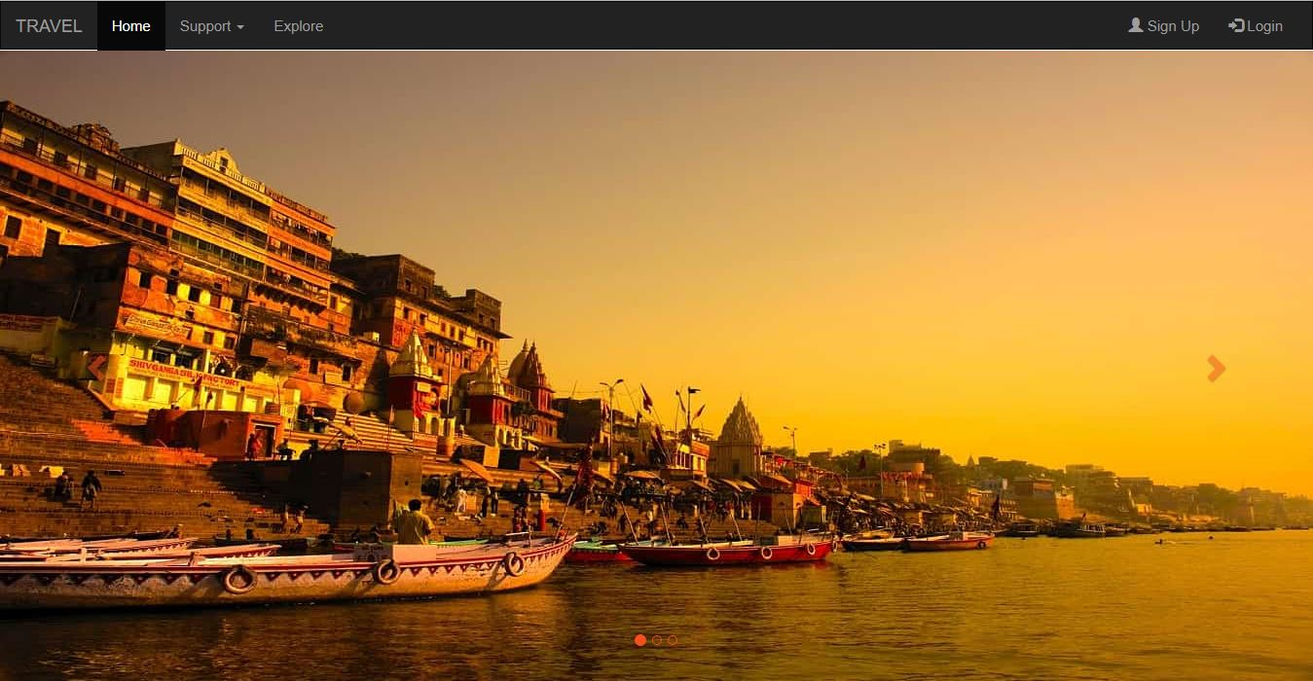**

**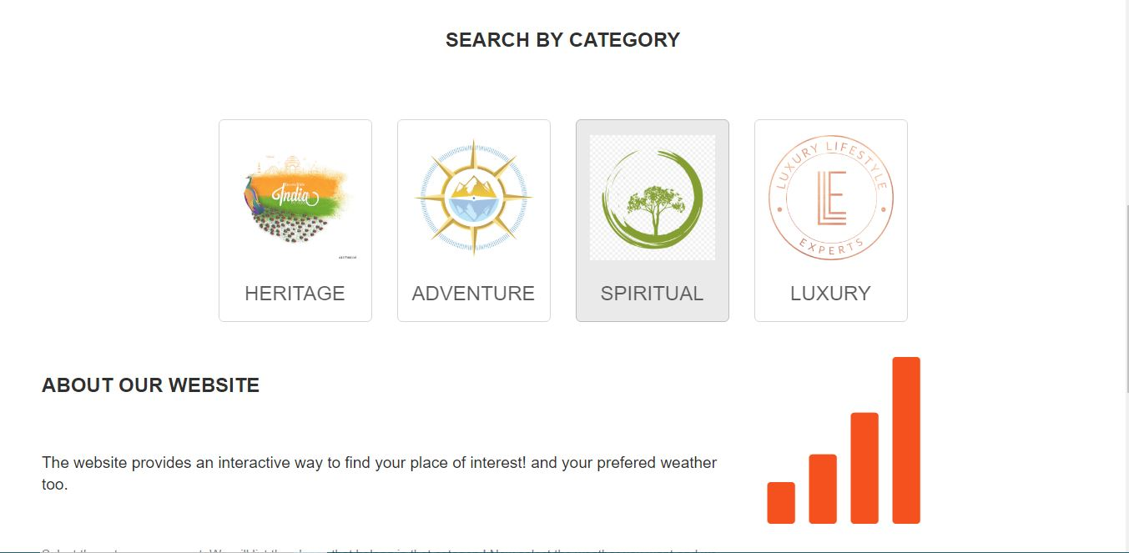**

**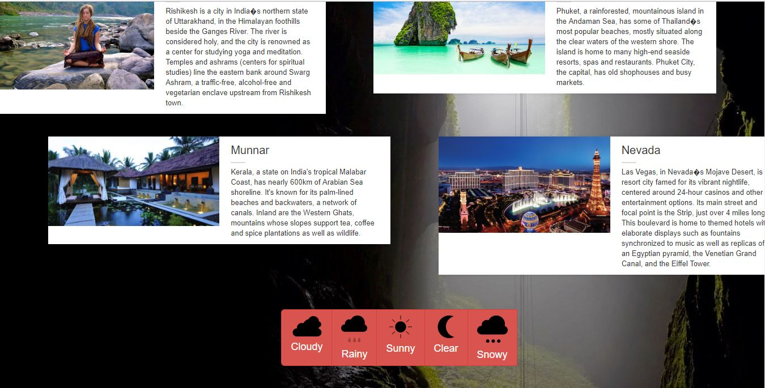**

**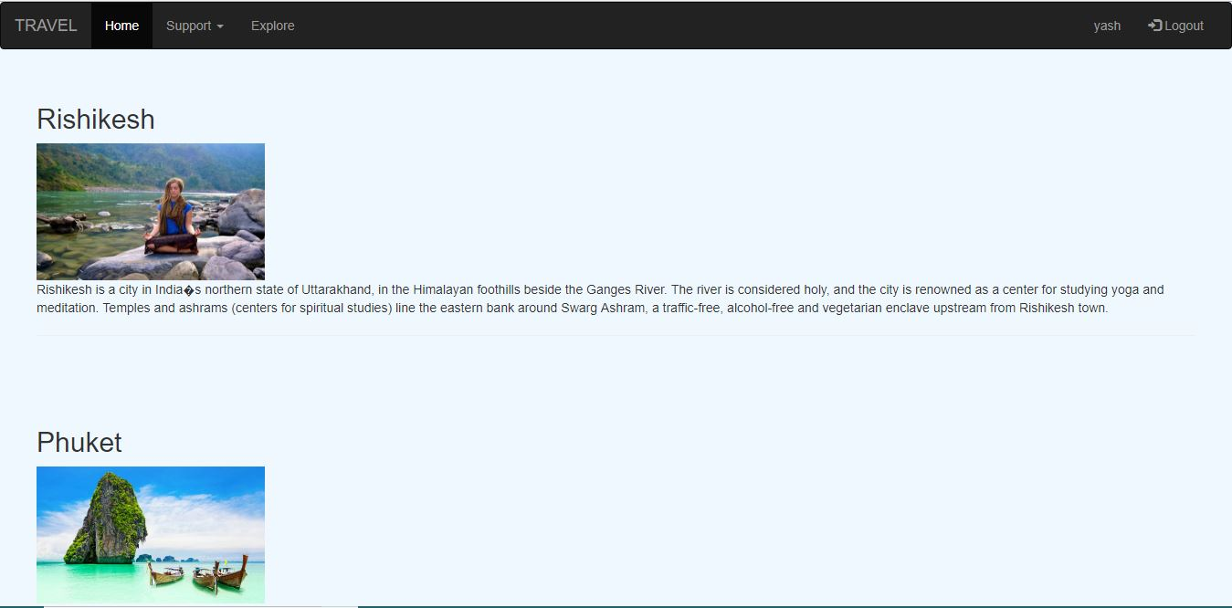**

**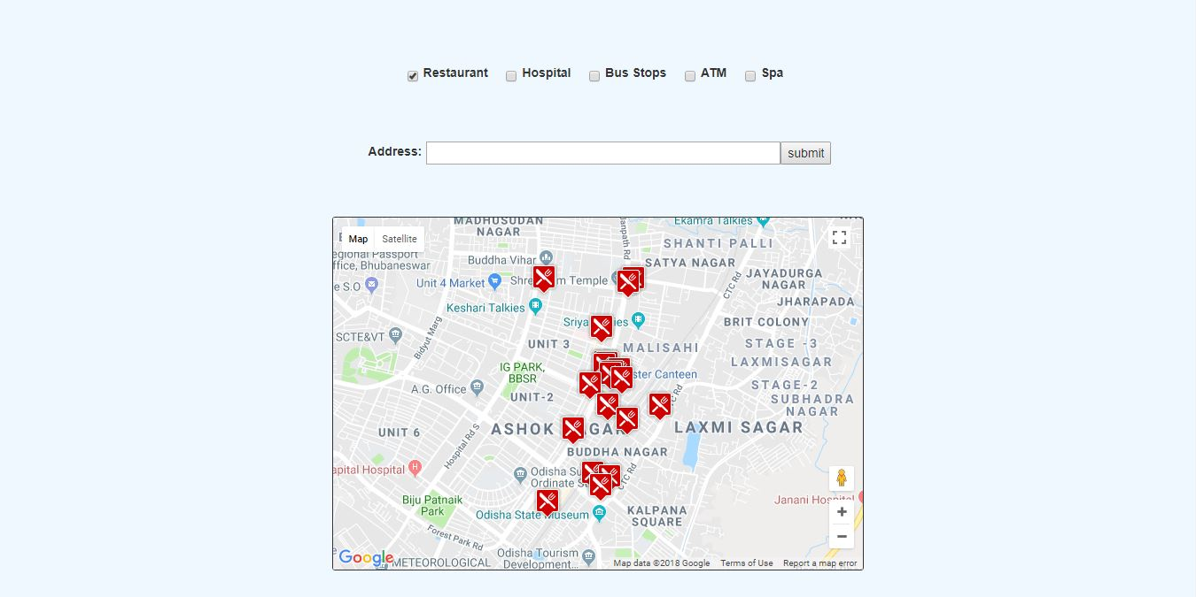**

**CHAPTER 5**

**TESTING**

**http://localhost/Minor/index.html**

**CHAPTER 6**

**CONCLUSION**

This application is developed to provide best travelling suggestions to the customers. We have developed ‘TRAVEL’ to provide a search platform where a tourist can find their tour places according to their choices. This system also helps to promote responsible and interesting tourism so that people can enjoy their holidays at their favorable places. This system also provide a better way to connect with various events. This system also gives tours related information like which places are tourist attractions, nearby restaurents bus stops etc.. Tourist can also get the Map and navigation system and temperature and weather information.. I express my deepest thanks to Ms.Razia Sultana Ma’am for helping us and guiding us all way along. This would really help me in my next internship which I prefer to do in Web development. I hope I would make the best use of my knowledge.

**REFERENCES**

1. www.w3school.com

2. [www.gousa.in](http://www.gousa.in)

3. Step by Step HTML5

By- Faithe Wempen

1. Internet & World Wide Web How to program

By- P.J. Deitel & H.M. Deitel